NEUTRALIsATION Reactions

**BACKGROUND:**

When an acid is mixed with a base, a reaction called **neutralisation** occurs.

* **H+** ions from the acid react with the **OH-** ions from the base to produce **WATER**.

**H+ + OH- H2O**

* The positive ion from the base combines with the negative ion from the acid to form a **SALT.**

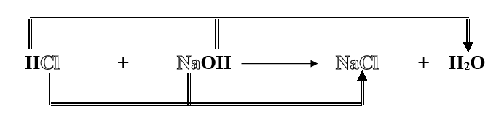

**AIM:** To neutralise an acid.

**MATERIALS:**

* Dropper bottles of

0.1M HCl

0.1M NaOH

* Universal Indicator and colour card
* test tube and rack

**METHOD:**

1. Place 5 eyedroppers full of HCl into a test tube.
2. Add 2 drops of Universal Indicator.
3. Add 4 eyedroppers full of NaOH to the test tube, then slowly add NaOH drop at a time until you obtain a neutral solution.
4. If you go past a neutral green solution and the liquid in the test tube goes blue then add acid to make it green.

**Questions:**

1. What colour was the HCl when you added the universal indicator?
2. What happened to the colour of the solution when you started to add NaOH to it?
3. What is meant by the term **“neutralisation”** in a neutralisation reaction and how do we know when the neutralisation has occurred?
4. Complete this general statement that summarizes the neutralisation reaction:

### Acid + Base ________________ + ________________